District Rocky Mountain held its winter meeting at Prost Brewery in Denver on February 8th. Over 180 people were on hand to listen to Bill Eye, the founder of Prost Brewery, speak on the subject of “Brewing in Copper: the Good, the Bad and the Polishing.” Although an exact headcount was not available, it is believed that it was one of the most highly attended meetings in District Rocky Mountain history!

The meeting started off with a social hour where attendees were invited to sample beers and take self-guided tours of the production facility. Bill was on hand at the top of the brewhouse deck to answer questions about the beautiful copper antique vessels. Prost makes only traditional German style lagers, and the Keller Pils, Dunkel, and Weissbier were all universally enjoyed. Once the bus from Fort Collins arrived, Bill got up on the bar and led the crowd in a toast and a rowdy rendition of “Ein Prosit”. After the social hour, a traditional German dinner of bratwurst and schnitzel was served.

District President Gary Dick kicked off the meeting with a very brief business meeting. He thanked Prost Brewery for hosting the meeting. He then mentioned that District sponsored scholarships were available to all members in good standing, with at least one year in the District. Details of the application process are on the District website. Lastly, Gary reminded the group that the next meeting will be held at New Belgium Brewery in May.

Gary ceded the floor to Technical Chairman Finn Knudsen, of Knudsen Beverage Consulting, who introduced the guest speaker, Bill Eye. Bill has been brewing professionally for over 15 years, and has won many awards – both for his beers and as the head brewer at Dry Dock when it was voted Small Brewing Company of the Year at the Great American Beer Festival. In his latest venture, Bill thought that it would be cool to go to Germany, buy an antique brewhouse, ship it across the ocean and make traditional German lagers in Colorado. The all copper brewhouse, which is unique to the area, presented Bill with some interesting challenges in the brewing process.

Bill started off by explaining how copper reacts with hydrogen sulfide, which is the biggest effect that copper has on beer. H₂S reacts with copper ions to form copper sulfate, which precipitates out of solution. The wine industry has done a fair amount of research on the subject, but most of what Bill has been able to gather from the brewing industry has been anecdotal. Because copper from the brewhouse transfers to the wort, it continues to reduces the sulfur compounds. Because they reduce more quickly than without the copper, Prost can close their fermenter vents sooner and are able to capture more natural carbonation. Copper also has the added benefit of being a yeast nutrient. Additionally, the copper requires far less cleaning than stainless. If anything, Bill has found that the copper vessels are cleaner after brewing than before!

However, copper can also have some negative effects, which Bill described. Copper is mutagenic to the yeast. It accumulates in the yeast cells over time and weakens their vitality. He did tests to determine to what extent the levels of copper, iron, and manganese affect shelf life, as all three metals are oxidative agents.

After the presentation, Bill was thanked again for speaking with an engraved mug from the Rocky Mountain District. And as is customary, the evening concluded with a very lively raffle of prizes supplied by many of the members, using a new ticketless format. The next meeting of District Rocky Mountain will be held in Fort Collins on May 6th 2013, at the New Belgium Brewery.

Tamar Banner
Publicity Chair
Master Brewers Association of the Americas - District Rocky Mountain
February 15, 2013
Attached photos:

Photos 1-3: Bill Eye explains the details of the brew kettle. The copper vessels and pipes were the stars of the show.
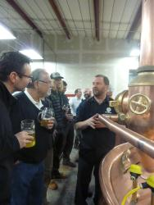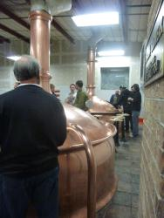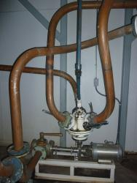
Photo 4: Finn Knudsen presenting Bill Eye (Prost) with an engraved mug.
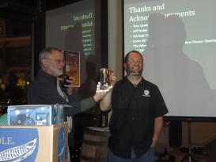
Photo 5: Barry Labendz, Drew Martinez (Odell), Matt Gilliland and Gary Dick (New Belgium).
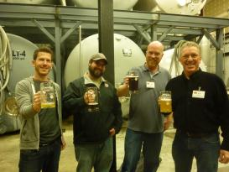
Photo 6: Brad Landman (Mountain Sun), Josh Willet (Fort Collins Brewery), Jason Zumbrennen (A.C. Golden), and Adam Glaser (FCB).
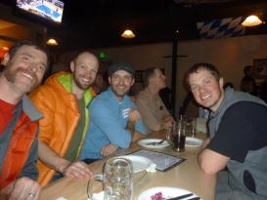
Photo 7: Rob Christiansen (Avery), Mark Fischer (New Belgium), Matt Thrall (Avery) and Kelly Tretter (New Belgium).
